# **BornToSurviveGame (BTS)**

– a world class AAA P2E and PvP game/metaverse

## Game Set-up

Earth is going through multiple challenges, scarcity of food, famine, and a pandemic which wiped out half the earth’s population and is being continuously raided by aliens and extra-terrestrial life. In order to survive they would have fight to survive and keep growing

BornToSurvive is not only a game but a metaverse. The actions here mimick the actions in the real world, or, inspired by real-world actions.

The MetaVerse would have:

* Gym and Training Ground - to train and improve their skills, strength, power
* Rest and Restaurant – to rest, eat and stay healthy.
* Vehicle Garage and more TBD

## Game Outline

BTS is a AAA-class First-person Shooter (FPS) video game in the metaverse, where gamers fight against the environment (P2E), and each other (PvP) to complete different challenges/missions, to unlock teleportation and time travel in the metaverse. **The game is a battle between 4 factions**, with each gamer contributing to gather rare NFTs across different missions, levels, and PvP. BTS can be played both in First Person Shooter (FPS) and Third Person Shooter (TPS) mode.

The goal of the game is to unlock time travel for their faction. The faction that unlocks time travel gets to progress to the next season, with their Heroes, Weapons, Levels, and NFTs, and they get certain advantages as the game progresses.

In BTS – the players can play the game to earn rewards. The game play will unlock different rare NFTs, opportunities to upgrade NFTs, weapons, Armours, Avatar and more. Some gamers can dedicate themselves towards farming of weapons, avatars, armours, etc, while others towards progressing on the challenge and achieving goals. Additional rewards, NFTs, tokens are subject to the discretion of the BTS token holders.

**Note**: Once launched, BTS would be community driven. Investors, developers, and gamers, with certain amount of BTS tokens, would be able to vote on various motions and proposals.

## The Gameplay

There are 2 different types of mining/progress needed. These can be done by a single gamer/hero, or collaborate with other gamers to move forward in the mission.

**Heroes** - As Heroes progress thru the armies, they need to keep upgrading themselves and level up. The alien army gets increasingly tougher and more difficult to kill and move thru.

* There are 100+ base heroes, available in NFTs. Each Hero has different traits, e.g. Speed, Agility, Strength, Power, and Skills. Some might have some meta-skills which could be temporary and/or permanent. As they progress thru different levels, the Heroes level up using different NFTs.

**Note**: These NFTs can be traded, leased, and sold in NFT marketplace – (TBD)

**NFTs** - Increasingly, higher levels of weapons are needed as they progress thru the armies. The weapons can be upgraded by minting NFTs and upgrading their weapons in the forge. There are different forgeries, with different levels of weapons being made.

* Guns and Ammunition
* Armors and Protection
* Vehicles and Transport
* Resources, Elements, & Compounds – used to forge weapons, build schools/infrastructure and plant trees
* Gems and Rare Metals
* Skins, Suits

**Note**:

* a limit would be imposed on how much NFTs a single wallet/individual can collect.
* All these NFTs can be either bought or leased at market price using BTS token (some of these NFTs would be own by game – so as to provide service to gamers, even when no one else is)
* Some of these NFTs would be breedable, which could be used in-game to generate an offspring aka a new NFT (more details to come)

## Game Economy:

BTS economy is designed to take into consideration different stakeholders and goes both deep and wide, connecting gamers, investors, and traders in every aspect of the gameplay. There are 3 segments of the economy: Execution, Development, and Ecosystem.

Rewards from skilled gameplay (**Execution**) are the main source of input into the game economy. These rewards flow into the Development and the ecosystem creating a thriving economy.

Components to build the in-game assets come from the **development** segment. Along with mining new Guns, Ammunitions, Vehicles, Armors, and more, NFTs for upgrades and elements to help upgrades are also mined. The number of NFTs available are either Minted with Proof of Play, or DAO governed ensuring transparency and fairness.

It is not just a game, but a metaverse. The **Ecosystem** helps the game progress eg: Weapon Forgery, Gymnasium, etc playing the important role of enabling upgrades, thus advancing the gameplay. These places themselves also need to level up, to be able to serve a higher level of upgrades.

### Earning:

BTS tokens would be earned by players as a reward to every kill. As the Hero kills the enemy, they get tokens in rewards on every kill. As the levels increase, the kill rewards increase as well.

The kill reward is with in-game tokens. These tokens can be traded for goods/services in the marketplace or converted to other tokens in the exchange and withdraw funds. And these tokens could also be used to improve the environment and infrastructure.

Simultaneously, earned tokens would be lost if hit by enemy. Similarly, if periodic updates are not made in the game, eg: taking rest, training, and going to gym would also result in loosing tokens.

### Burning:

Simultaneously, earned tokens would be lost if hit by an enemy. Similarly, if periodic updates are not made in the game, eg: taking rest, training, and going to gym, it would result in losing tokens.

If the Hero dies, a percentage (20%) of the tokens, resources, and NFTs carried by them at that moment is lost. There is a need to carry more tokens in the game to be able to mint Rare NFTs, and at the same time, there is this risk of losing 20% of the tokens if they get killed during the process.

### Tax:

A tax of 10% on earned tokens & in-game assets and NFTs - 50% of which would go to R&D fund and 50% tokens would be burned

## Tokenomics

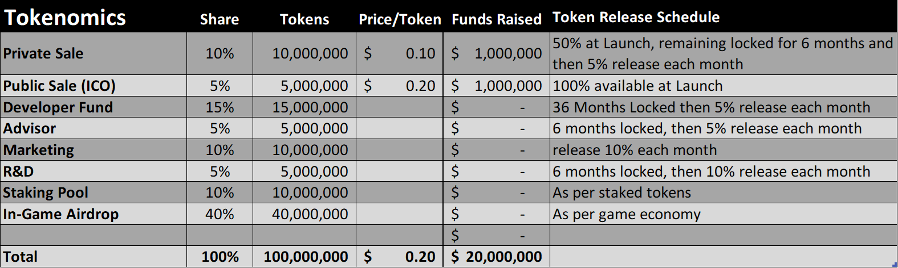

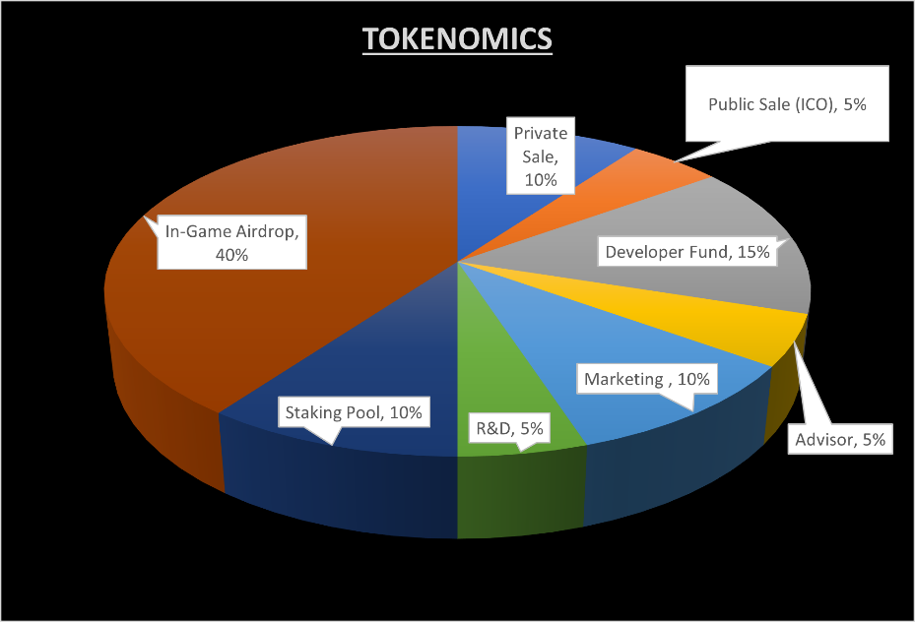

## Game Assets

### BTS Tokens

A unique tokenomics to control inflation. Max supply of 100 million tokens.

### Genesis NFT

All the Genesis NFTs are available for staking in the game. Different genesis NFTs have different staking multiples and different rewards defined as well.

This NFT staking works:

* There is a start date for staking the NFTs.
* There is a grace period to be able to withdraw staking. Once staked, the NFTs will not be open for trading till all the NFTs are staked and rewards distributed. (This is to prevent new investors from getting cheated by buying NFTs expecting rewards when they have already been claimed.)
* Some of the genesis NFTs can only be staked with a certain multiple. (details soon)

### Hero NFTs

Heroes form the core of every gameplay. That makes these NFTs one of the most sort after NFTs in the BTS metaverse.

### Hero NFT Derivatives

As the game gains popularity, rather than selling more Hero NFTs, we will be giving Hero NFT Derivatives, benefitting all investors.

### In-Game Assets NFTs

Every gun, jacket, night vision goggles, car, etc in the In-Game Asset list is an NFT, that can be traded, and used in the gameplay.

### Upgrade NFTs

Gamers will be able collect upgrade NFTs during gameplay. Upgrade NFTs are available for Guns, Knives, Armours, and even Heroes. These can also be traded in the marketplace.

### Resource NFTs

Resource NFTs are an unique aspect of BTS. It plays an important role in the metaverse. These are tradable on the marketplace.

### Rewards:

* **Heroes NFTs** - Airdrop of Heroes NFT to Genesis NFT holders who have staked. People can stake/claim their Heroes NFTs later, when they find the multiple to stake and claim.
* **Access Packs** - Genesis NFTs staked will get Access Packs in Airdrop. The number of Access Packs or the type of packs will differ. These airdrops can happen at any time. If any NFT is not staked, they can claim theirs later after staking.

**In-Game NFTs Airdrop/Claim** - Guns and Armors will be airdropped to genesis NFT holders as well. Like the previous ones, these can also be claimed later after staking.

**In-Game Tokens ($BTS)** - $BTS tokens will be rewarded on a block by block. These tokens will be locked and released 2.5% on TGE and then linearly over a period of 2 years. Post TGE, there will be rewards as well, and their details will be updated soon. (Unlike, the previous rewards, if NFTs are not staked, the token given earlier will be missed and can not be claimed later.)

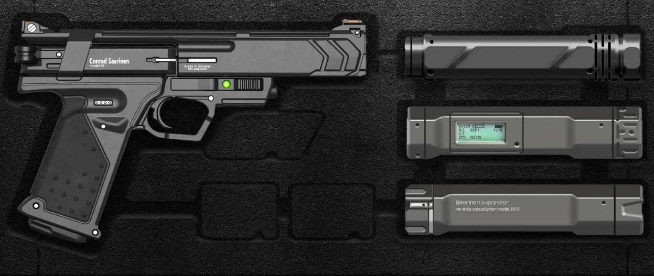

**Coding**:

* Create ERC20 Token (BTS) – Tax 10% - 50% Burn, 50% R&D
* Create Smart Contract ERC20
* Create 1-2 ERC721 (NFTs) - **Images**
* Create ERC20 Airdrop / Earning (Play to earn) SmartContract
* Create ERC20 Burnable SmartContract

Tokenomics:

* New NFT game – get initial fundings -12 months
* No. of tokens ERC20 tokens **Max Supply** – 100 Million
  + Raise $10 mill (10% tokens) – $0.01 -
  + ICO / IDO (Initial DeX offering) – 5% would be sold to public to raise $10 mill $0.02
  + **TGE** – Token Generation Event – ERC20 tokens SmartContract would be created
  + 60% of tokens would be through Play to Earn

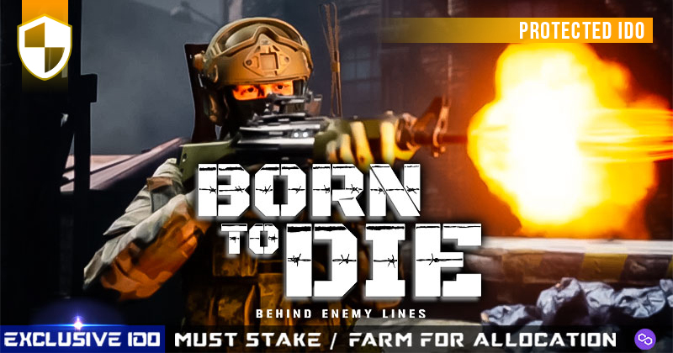

**A Blockbuster is coming**

**BORN TO**

**SURVIVE**